Fieldwork Report
Sikhism and Guru Nanak Nishkam Sewak Jatha (GNNSJ) Gurudwara
The GNNSJ gurudwara in Beeston, Leeds, attracts Sikhs from all over the local area. Devout lay people as well as curious visitors are equally welcomed into this now holy building that once operated as the Rington’s Tea Company until 1986. I was keen to explore this small but vibrant community’s presence in Leeds and the way they interact with their surroundings in relation with my research on diaspora communities. How much have they acclimatised with so called ‘British’ culture? Is Sikhism truly as egalitarian as my research would have me believe, and how do they maintain this in their practice?
I contacted the jathdar (leader of the jatha or clergy) by email through the gurudwara’s rather well made and informative website. The response was quick, friendly and clear and through further correspondence we decided on a convenient date for me to observe worship. We were treated warmly and welcomed as if honoured guests, the atmosphere very homely with a majority of elderly volunteers preparing the daily langar meals, a free meal offered to anyone who enters the premises, regardless of faith, ethnicity or gender (See images 2 and 3). Before arriving at the gurudwara I was expecting to feel like a firm outsider, even though my ethnicity means that I originate from the same country as Sikhs – India. However, upon arrival I found that there was virtually no language barrier, even though I do not speak Punjabi, my understanding of Hindi meant I could follow conversations around me. The food served and clothes worn were close to home. Perhaps the terms ‘insider’ and ‘outsider’ are not as black and white as they seem but rather on a continuum. Junker and Gold in the 1950’s developed 4 different stages ranging from ‘Complete Observer’ as the outsider to ‘Complete Participant’ as the insider, there then can be the possibility of many different ‘gradients’ of insider (Knott, 2010, p.262). Although I am not a Sikh, being brought up Hindu meant I saw many similarities between the physical manifestations of the religion, an atmosphere I was used to, making me feel less nervous about the whole experience. It was interesting how quickly my own assumption that I was very much an outsider shifted as I realised that I had basic knowledge already, from knowing how to cover my hair and when to remove my shoes to being able to sit cross legged for a long period of time. This is not to say however that I was anything like an expert; aspects of the religion really surprised me, especially as I was consciously comparing what I saw to my Hindu background.
Sikhism in Leeds is one of the smallest of the major world faiths with 0.8 % of the population identifying themselves as following the Sikh faith in the ONS 2001 census. Simultaneously this is known to be a much larger diaspora religion than Hinduism (Nesbitt, 2005, p.86) as many Sikh Punjabis arrived in the UK after leaving Africa due to Idi Amin and also Africanisation. I spoke in great detail with the jathdar who told me how he was born in Africa, worked there successfully until deciding that they must leave to get a better education for their children. After disliking life in India they settled in the UK and he has since been the leader of this gurudwara for about 40 years. From talking to the lay people I realised that most of the elder generations had either moved from East Africa or from India, with the majority from the former. However, there is not a very large population of Sikhs in this particular part of Leeds (Beeston) as many moved away when the area became more deprived. There is still a healthy congregation as many travel from the surrounding areas,for GNNSJ is the only gurudwara in South Leeds.
I was informed that the general prosperity of the area isn’t high which has led to them having some problems. For example, the concept of langar is that food is accessible to all, however Sikhs also do not tolerate drunken or disorderly behaviour in the gurudwara due to the presence of the holy Guru Granth Sahib. Therefore they have come up with a wonderful system of packing plastic boxes of food to give to people that come to their doors but cannot be allowed in for whatever reason. In this way the gurudwara has adapted to its surroundings, maintaining both the principles of the Sikh way of life as well as keeping a good relationship with members of the local community. I feel that this simple example of compromise for good relations shows how the Sikh community in Leeds has managed to integrate successfully. GNNSJ also receives many curious visitors that are not Sikh. While we were visiting there was a large group of about 20 white, British women who had come all the way from York to experience langar and worship at the gurudwara. This was something I had not expected to see, none of the women identified themselves as Sikh but there was a mutual air of comfort on both sides that meant they had a rewarding visit.
For the duration of our visit I chose to take written notes when I felt it appropriate, such as when specifically talking to people. However for the most part I felt like it was more useful to participate actively, talking more informally during the langar meal and also listening and observing during the time when we were seated in the main hall. Whilst in the hall I also recorded the chanting on my phone, in order to potentially re-visit how I felt while listening to the poetic words being read from the Guru Granth Sahib (see image 4). This was where my very basic understanding of the language failed me; being unable to recognise the words being chanted meant that suddenly I felt like an outsider unable to participate, as I had no knowledge of what I was listening to. Sikh communities in the UK firmly hold on to the language they were originally brought up with, at GNNSJ there is a Punjabi school set up for the children to learn their mother-tongue. This allows young Sikhs to better appreciate scripture as well as to communicate with other members of the community. By firmly holding on to language it may be interpreted that the community has not integrated that much into British culture as, by not speaking Punjabi, it is easy to become confused, no matter how friendly and helpful members of the jatha are. In this way my role was somewhat compromised, it may have been more effective if I could actually understand what was being said. However, gurudwaras have been used for people to bond with others of the same community in a culturally familiar place (Nesbitt, 2005, p.91), something that ‘twice migrant’ East African Sikhs in particular knew to be very important. This is why after they migrated to the UK the number of gurudwaras increased. These cultural places act as a comforting reminder of shared identity that was quite obvious to see in the way people communicated with one another.
Another aspect of Sikhism that very much interested me was the ‘notably more positive attitude towards women’ (Shackle, 2009, p.106). At first glance I couldn’t quite understand how this was manifested in GNNSJ. I then saw that both man and women cooked and served in the kitchen and that both genders were expected to cover their heads out of respect and remove their shoes. Men and woman have equal roles within the community. One individual told me that women are given the title name of ‘Kaur’ which means ‘princess’ while men have the name ‘Singh’ meaning ‘lion’, after ‘Khalsa’ (a type of ‘baptism’), as the Gurus saw all humans to be equally powerful. Interestingly the jathdar mentioned that in India all people, regardless of gender, sit together in front of the Guru Granth Sahib while, as far as he has seen, outside of India this is not the case as woman sit on the left and man on the right. Indeed when we went to sit in the main hall, we were led to sit on the left with other women. The jathdar did not know a reason for this odd segregation of genders before the Holy Scripture, which makes me wonder what it is about the west that has caused a community to go back on their own values. Has secularisation somehow motivated a fear that has resulted in going back to a tradition that predates the religion its self?
Many of the first Sikhs in the UK set up a room in houses for the Guru Granth Sahib, only being able to purchase large buildings to convert to gurudwaras in the 1960s and 70s which coincided with the arrival of ‘twice migrants’ from Africa. GNNSJ however was only made in 1986 from a building built in 1927 and set up as the Rington’s Tea Company (see image 1). I was told that the youth of the community in particular helped to paint and maintain the appearance of the gurudwara as an attempt to make them feel more included. The large variety of secular activities provided, from archery to sewing, may indicate that the gurudwara is openly accepting secularisation. Next time I would like to observe one of these activities to determine how much they relate to the religious identity of the individuals who participate in them, or whether the building is simply being used as a convenient space. I think it would be interesting to see how this more secular culture has affected younger Sikhs, and whether they feel as much of an insider as first generation migrant Sikhs. I question whether the religious part of their life is simply something they have grown up with but lack understanding of. How do third or fourth generation Sikhs identify themselves with ancestors that did not live in this country? Do they really know what it means to be from India if their family has few, if any, ties to what was once the country of their origin? From my fieldwork at the gurudwara I saw mainly elderly volunteers, Sikhs who have known some form of practice before the GNNSJ gurudwara, I would like to know how their experiences differ to those born in the UK.
In conclusion I believe that the Sikh community of the GNNSJ gurudwara in Beeston, Leeds has successfully integrated with the local community whilst also maintaining their own individual attributes such as the Punjabi language, langar food, and traditional main hall. The addition of secular classes within the gurudwara building may show a form of acceptance of secularisation. Alternatively this could be a way to encourage the later generation Sikh youth to participate in the gurudwara life. I think that this type of fieldwork was invaluable for learning how equality is maintained in Sikhism, as well as for showing how their practices can make an ‘outsider’ feel more welcome than they would expect.

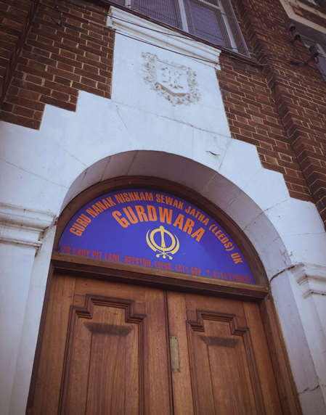
Image 1.
The main entrance to the gurudwara has been adapted to reflect its purpose. The shield above may refer to it’s original use as the Rington’s Tea Company building.
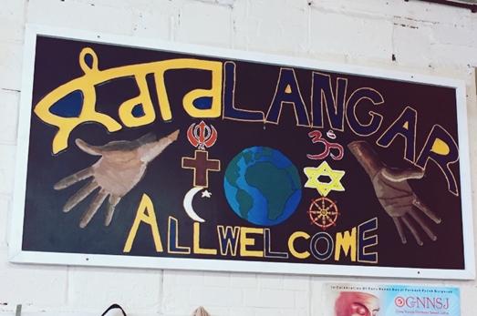
Image 2.
Shows the friendly sign of welcome above the langar hall.
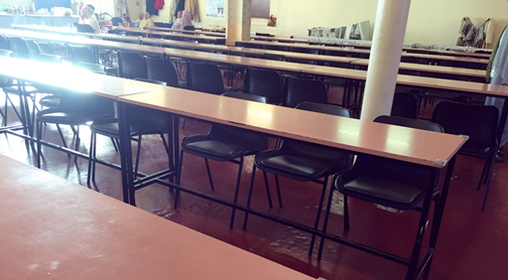
Image 3.
The langar hall at GNNSJ has long rows of tables and chairs unlike a traditional gurudwara where people sit on the floor for their meal.

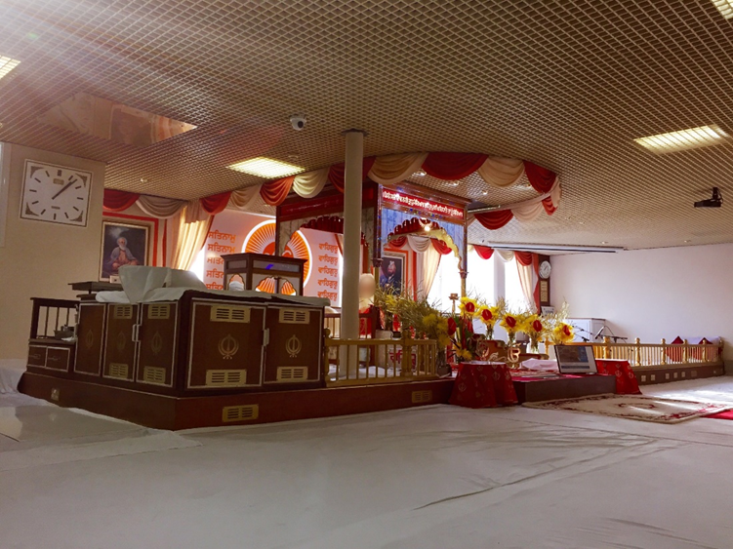
Image 4.
The main hall where the Guru Granth Sahib is being read from. Sikhs bow to the holy scripture before sitting on the floor to listen to the chanting, reflecting upon the teachings being read. ‘Prashad’, a blessed sweet, is offered to all those that sit here.
The reader’s face has been blurred out.

Bibliography:
Knott. (2010). 'Religion and Diaspora'. In Hinnells, J. (eds) The Routledge Companion to the Study of Religion, London and New York: Routledge, Second edition
Nesbitt, (2005). ‘Sikhism outside India’ Sikhism : a very short introduction, OUP pp. 86-104
ONS. 2011. [Online]. [Accessed November and December 2015]. Available from: http://www.ons.gov.uk/ons/rel/census/2011-census/key-statistics-for-local-authorities-in-england-and-wales/rpt-religion.html
Shackle. (2009) ‘Sikhism’. In Woodhead (eds) (2009) Religions in the modern world: traditions and transformations London: Routledge. Pp. 103- 117.

Word count: 1967 words

