Fieldwork Report

Leeds Grand Mosque

For the purpose of my study, I visited Leeds Grand Mosque, Woodsley Road, Leeds. I first visited to carry out my fieldwork observation on Monday the 9th of November 2015 and then again to an event organised about the prevention of Islamophobia on Saturday the 28th of November 2015. The focus of my report was on the importance of a Muslim community and identity in Leeds and how this may have been shaped by effects of Islamic transnationalism and migration. Furthermore, I hoped to look closely at how the community’s experience of being Muslim in Britain may compare to an often negative perception of Muslims in the media.

When initially planning my fieldwork, I contacted the office manager requesting an observational visit to the mosque, with the hope of attending a session of daily prayers but I did not receive a reply via email, which made me question whether the mosque felt uncomfortable with a non-Muslim female visiting. However, a week later I phoned the office number supplied on the website, which proved very successful as the officer manager’s response was friendly and welcoming, inviting me to attend Maghrib prayers, the fourth prayer of the day, at 4.30pm. This highlighted that despite the professional and informative website, the best form of contact was directly via phoning, which also gave me a more personal response prior to the visit.

With the visit arranged, I felt it appropriate to research the origins of Islam in Britain and the history of Muslim communities in Leeds. Being brought up in a loosely Christian Baptist family, the focus was not necessarily on attending church and being part of a religious community but on the importance of understanding all faiths and religious beliefs. I was therefore very open-minded to learning about Islam, Muslim faith and worship – something I had never experienced first-hand. Prior to the visit I considered the etic viewpoint I held, described by Kenneth Pike as studying ‘behaviour from outside of a particular system’ (1967, p.37). Whilst conducting my fieldwork I kept in mind that I am an observer taking the information I gathered and ‘organizing, systematizing that information in terms of the system of their own making’ (McCutcheon, 1999, p.17).

I arrived early to the mosque at 3.45pm, so before entering I had time to look around the surrounding area and grounds of the mosque which pointed to an Arabic speaking community, with Halal takeaway restaurants and hairdressers featuring Arabic signs, making clear connections between the place of religious worship and the local worshippers. I discovered that the presence of Muslims in Britain can be traced back ‘at least three hundred years to the activation of the East India Company’ (Lewis, 2002, p. 11) before ‘Muslim seamen and traders from the Middle East’ (Abbas, 2005, p.18) began to settle in the early nineteenth century. Following this, a more significant influx was clear during the post-war immigration of the 1950s of ‘Pakistanis, Bangladeshis and Indians’ (Abbas, 2005, p.19) coming to take up labouring work, and from the 1970s onwards, beginning to study at universities, putting the focus of everyday life less on maintaining religious tradition but integration into British society.

My first impressions of the mosque’s appearance were very different to my expectations, which were of a grand building, with quite an ostentatious exterior and ornate décor. Instead, the building was large but plain and concrete, with no symbols associated with a mosque, such as dome roofs or minarets, making it look more like a community centre than a sacred space of worship. In fact, my university accommodation is five minutes from the mosque, meaning I have walked past it several times, but until the day of my visit I had not noticed that it was indeed Leeds Grand Mosque, highlighting its humble presence.

When I arrived it was not immediately clear where the female entrance was, creating feelings of anxiety as I did not want to cause offence by using an inappropriate entrance. However, I rang the office manager and he kindly came to meet me, putting me at ease. As I entered, I removed my shoes and asked whether I should put on my headscarf. I was surprised by his relaxed response that because I was not a Muslim and not participating in prayer, I did not have to wear a headscarf. Thus, within the first five minutes of my visit, my previous misconceptions of the Mosque’s strictness were dispelled, leaving a feeling of positivity towards the progressive and welcoming Muslim community I experienced.

I decided it was best to ask questions I had prepared before prayer began which the office manager was more than willing to do. I was interested to find out if Mosque was attended by a variety of ethnicities and nationalities. As part of the University of Leeds Community Religions Project, I found a study by Ron Geaves on Muslims in Leeds which states that Leeds Grand Mosque ‘*has certainly the most international congregation in Leeds. This reflects not only the numbers of Muslim students at the University but also the growing numbers of South Asian Muslims returning to University Ward’* (1995, p.12). My visit confirmed this and the officer manager explained that as the ‘grand’ mosque in Leeds, its community is a global one, made up of many Muslims from the Middle East such as Saudi Arabia, Iran and Iraq as well as South East Asia, Africa and Europe. Also, to accommodate for this diversity, the sermon at Friday prayers is given first in Arabic and then again in English, ensuring that the word of Allah is understood by as many as possible.

The mosque also has quite a far reaching interest, with individuals travelling from places such as Dewsbury (a thirty minute drive away) to attend prayers. This struck me as significant in highlighting not only the importance of attending the mosque for prayers but also the role of the mosque as a hub of religious activity and community. This idea was stressed further as the officer manager explained how the mosque is particularly popular with international male students from the universities, who experienced a culture shock upon arriving in Britain, leading them to become distracted by socialising, drinking and girls. Thus attending the Mosque provides a source of nourishment and desire to retain their faith. Moreover, Geaves (1995, p.12) suggests ‘*the presence of the Grand Mosque means that once again there is some contact between Muslim students and the migrant community’,* contrasting with the previous focus of Muslim immigrants and showing the importance of maintaining a Muslim identity in British society.

At 4.10pm I was shown to the female prayer hall, which looks down onto the main hall where the Imam conducts prayers and men pray. I discovered that, originally a Catholic Church, the building became Leeds Grand Mosque in 1994, partly due to an increase of Muslims coming to Britain in the early 1990s. Being the first time I had seen the main hall, I was surprised by its size, with a capacity of 1,200 (an extension was added in 2013 as the mosque’s attendance was too large for the original capacity). It was very plain, with white walls and blue patterned carpet that covered the whole floor (Appendix A). There was a TV screen used during Friday prayers to broadcast the Imam’s sermon to the female prayer hall and those at the back of the mosque. There were a few bookshelves on the outskirts with copies of the Qur’an in a wide variety of languages, highlighting the need to accommodate for the variety of attendees’ nationalities. Although initially surprised by the simple décor, on reflection, it is clear the multipurpose function of the mosque as a place of worship but also a community base made its appearance more appropriate than an overly pretentious display, which may make the mosque feel unattainable to worshippers or outsiders like myself.

At 4.20pm, the Imam gave the call to prayer and whilst this was being conducted people began to arrive and take their place for independent thought and prayer. Soon after, Maghrib began and I observed both men and women praying, whilst making notes about the order of prayer and the repetition of the rak’ahs (parts of the prayer), two times out loud led by the Imam, and once in silence. The experience of witnessing prayer in such close contact was new to me and something that I found completely compelling. I felt that within thirty minutes I had had a small glimpse from an outsider perspective into the importance of praying in a mosque alongside other Muslims and worshipping Allah together.

By 4.30pm there were sixty men and three women praying. Within the men, there was a variety of age, ethnicity and dress. With the exception of four men, the ages ranged from 18-30. None were of white ethnicity but instead a variety of backgrounds, highlighted by the different styles of dress. Some wore thoub (white tunics) and gahfeyas (embroidered caps) native to Qatar, whilst others wore more ‘western’ outfits of jeans and t-shirts. I had assumed that those wearing traditional dress may have been older, perhaps the first generation of their family in Leeds, however, the forms of clothing were not prescribed to age groups, with many younger men choosing to wear traditional clothing, therefore highlighting the importance of maintaining cultural roots and traditions when living in Britain.

On Saturday the 28th of November I returned to Leeds Grand Mosque for a presentation by an organisation called MEND (Muslim engagement & development) on challenging Islamophobia in the UK and improving British Muslim participation in media and politics. The event was open for anyone to attend, highlighting the keenness of the Mosque to provide information to both Muslims and non-Muslims about preventing Islamophobia in Britain.

The presentation revealed alarming statistics regarding British attitudes towards Muslims and the portrayal of Muslims within the media. For instance, the concept of 21:1 shows that for ‘everyone one moderate Muslim mentioned, 21 examples of extremist Muslims are mentioned in the British press’ (Baker, et al. 2013), or the research that shows ‘whilst 82% of British Muslims consider themselves to be loyal to the UK, 61% of Britons do not believe Islam is compatible with British culture’ (Gallup, 2009). The information provided by MEND shows a continuous fuelling of negative ideas about Muslim communities in Britain, prompting me to carry out further research on the emergence of hostility towards British Muslims.

Abbas suggests that from a euro-centric perspective, ‘contemporary Muslims are identified as either terrorists warring against the West or apologists defending Islam as a peaceful religion’ (2005, p.50). Supporting this view, recent events such as *The Sun’s* misleading headline that 1 in 5 Muslims sympathise with Jihadists (Melley, 2015) highlight a lack of understanding of Islam’s real message, leading to seeing Muslim values as a threat to British ideals. Yet, the time I have spent with this particular Muslim community has revealed realities of a positive and progressive group. This is far from the offensive, and in many cases, dangerous rhetoric of the British media.

Conclusively, if I was to change anything about my visit I would have liked to have spoken to a few more individuals, hearing their experiences of being Muslims in Britain and how this might impact their own sense of identity in a wider community. However, overall I feel that my fieldwork has indeed been effective as I’ve not only been supplied with real experiences and first hand understanding of how a Muslim community functions in Britain, but have also been given an insight into Muslim responses to hostility in British society. Alasdair MacIntyre suggests that ‘to truly understand an insider one must become an insider; to understand is to be’ (McCutcheon, 1999, p.21). However, I would say that my experiences at Leeds Grand Mosque, although brief, lead me to disagree with MacIntyre’s analysis, for I gained comprehension of what it is to be an insider; I remain an outsider but with much possibility to ‘look in’.

Word count: 2002

References:

Abbas, T (2005). *Muslim Britain: Communities under Pressure*. London: Zed Books Ltd. pp.18-50.

Baker et al (2013). *Discourse analysis and media attitudes: the representation of Islam in the British press.* Cambridge: Cambridge University Press.

Gallup, (2009). *The Gallup Coexist Index 2009: A Global Study of Interfaith Relations.* [pdf] Gallup Inc. Available at: <http://www.olir.it/areetematiche/pagine/documents/News_2150_Gallup2009.pdf> [Accessed 1st December 2015].

Geaves, R (1995). Muslims in Leeds. In: *University of Leeds Community Religions Project*.

Lewis, P (2002). *Islamic Britain: Religion, Politics and Identity among British Muslims*. 2nd ed. London: I.B Tauris & Co.Ltd. pp. 10-27.

McCutcheon, R.T. (1999). Theoretical Background: Insides, Outsides, and the scholar of religion. In: *Insider/Outsider Problem in the Study of Religion*. London: Cassell. pp.17-21.

Melley, J., (2015). *Do 20% of British Muslims really sympathise with jihadists?.* BBC News, [online]. Available at: <http://www.bbc.co.uk/news/magazine-34967994>. [Accessed 3rd December 2015].

Pike, K. (1967). Etic and Emic standpoints for the description of behaviour. In: *Language in Relation to a Unified Theory of the Structure of Human Behaviour*. 2nd ed. The Hague: Mouton.

Appendix

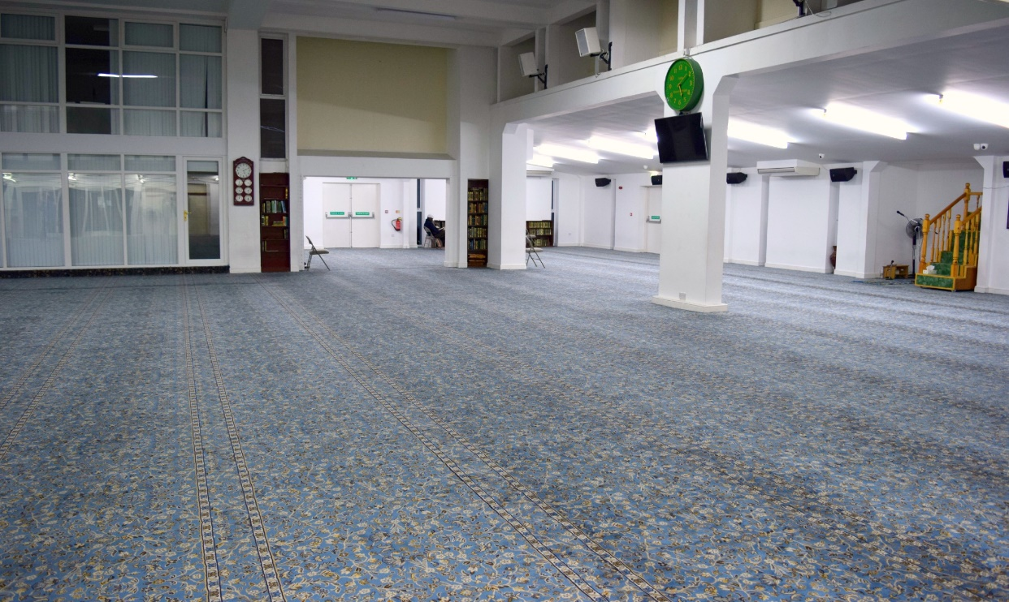Image A: A section of the main hall at Leeds Grand Mosque.